CORPORATE CARD SETUP FOR VISA
When you implement corporate credit card functionality, you must decide whether your company or its employees are responsible for paying the credit card issuer. The three payment options that you can implement in Expenses are the following:
Individual Pay: The employee pays the corporate card issuer for all corporate card transactions.
Company Pay: Your company pays the corporate card issuer for all transactions.
Both Pay: Your company pays the corporate card issuer for business expenses and the employee pays the corporate card issuer for personal expenses.
This figure shows an overview of the corporate card transaction files processing.
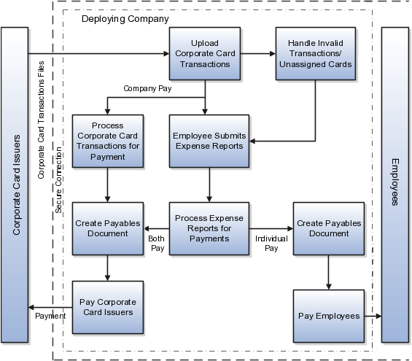

Following are the Setup Steps for the same
Visa file format will only get uploaded if the encryption of the file is enabled. The file will get encrypted using Public Key whose setup can be done from below.
Navigation: Navigator > Tools > Security Console > Certificates
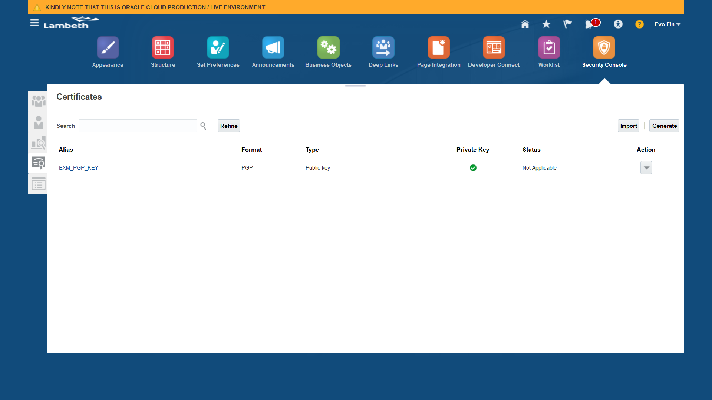
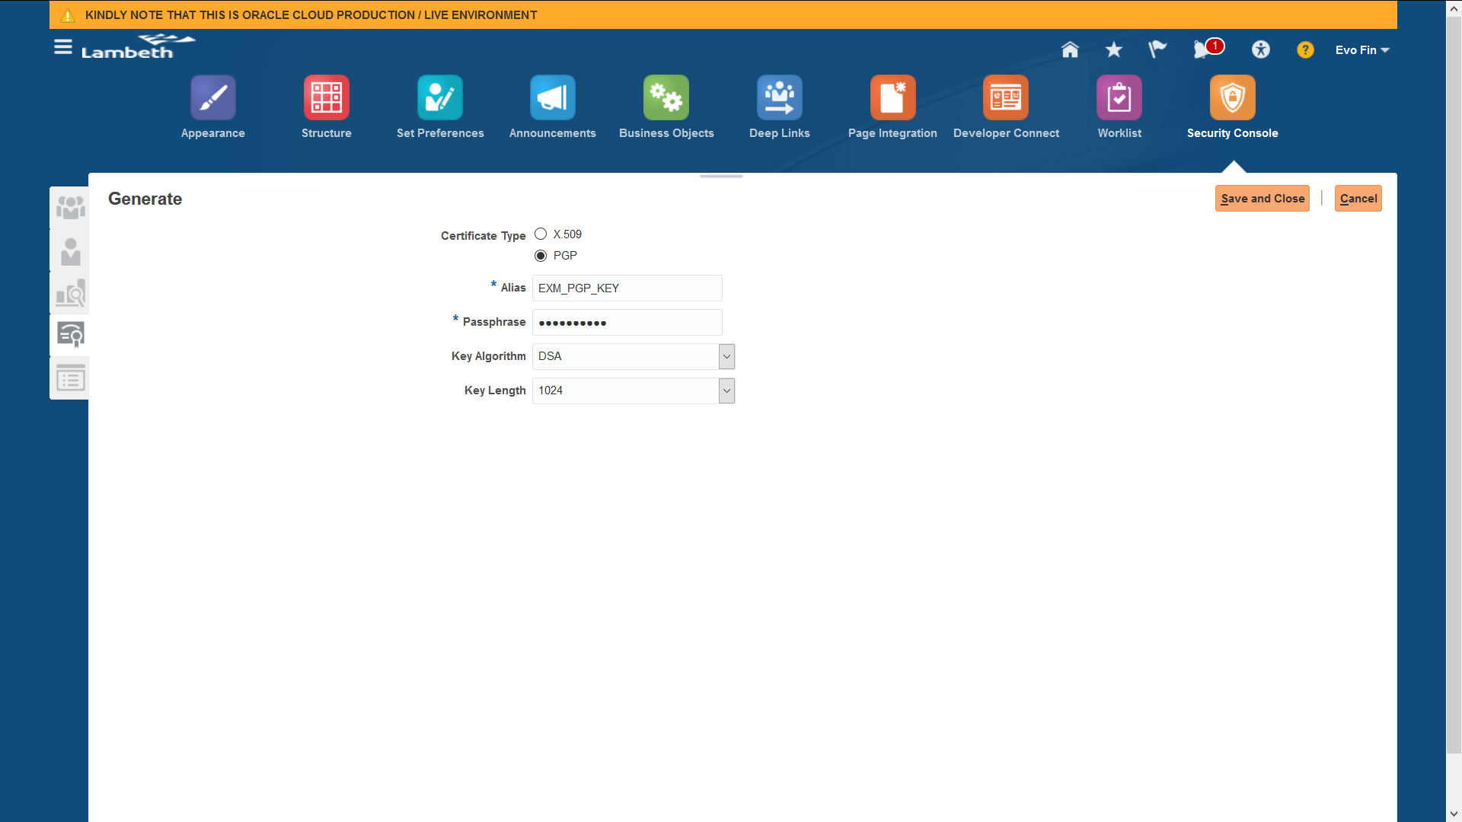
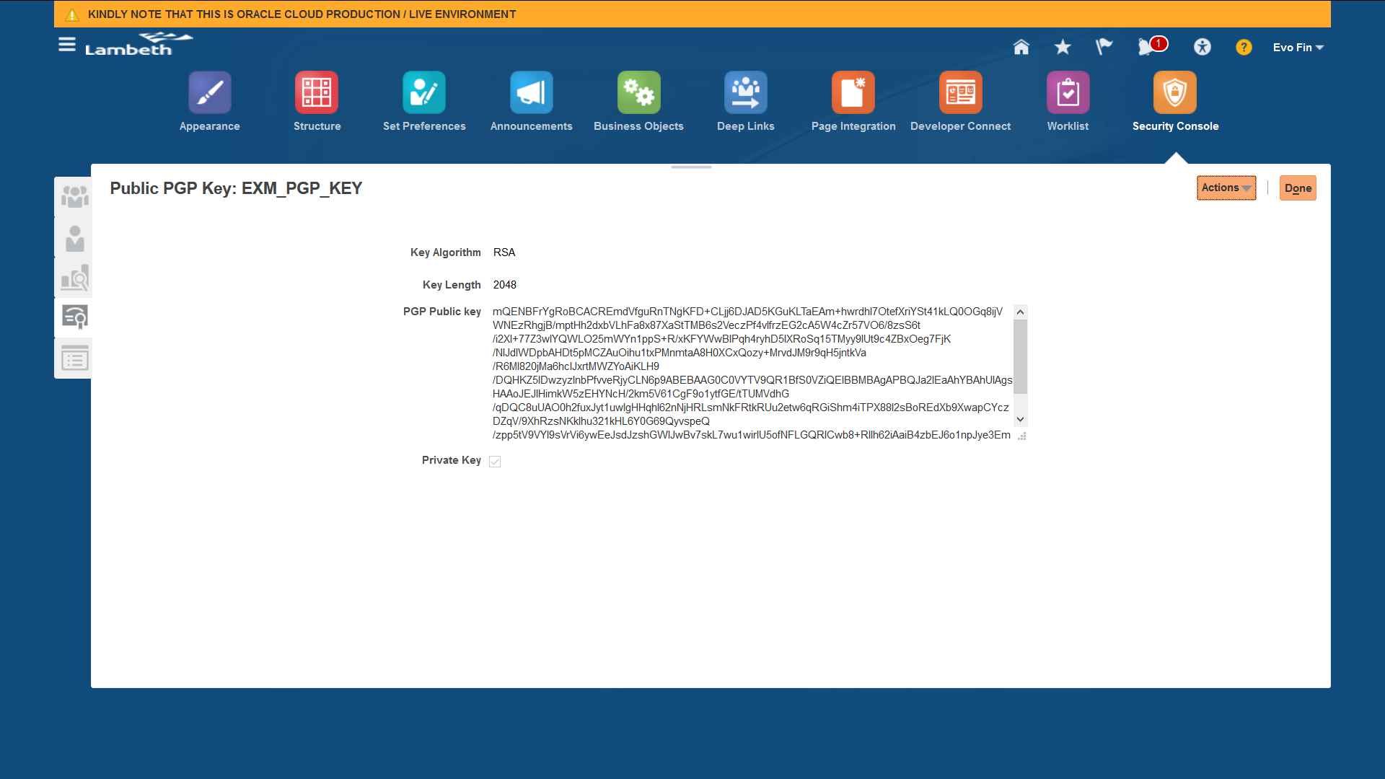
Also, encryption is to be enabled from Manage System Security Options
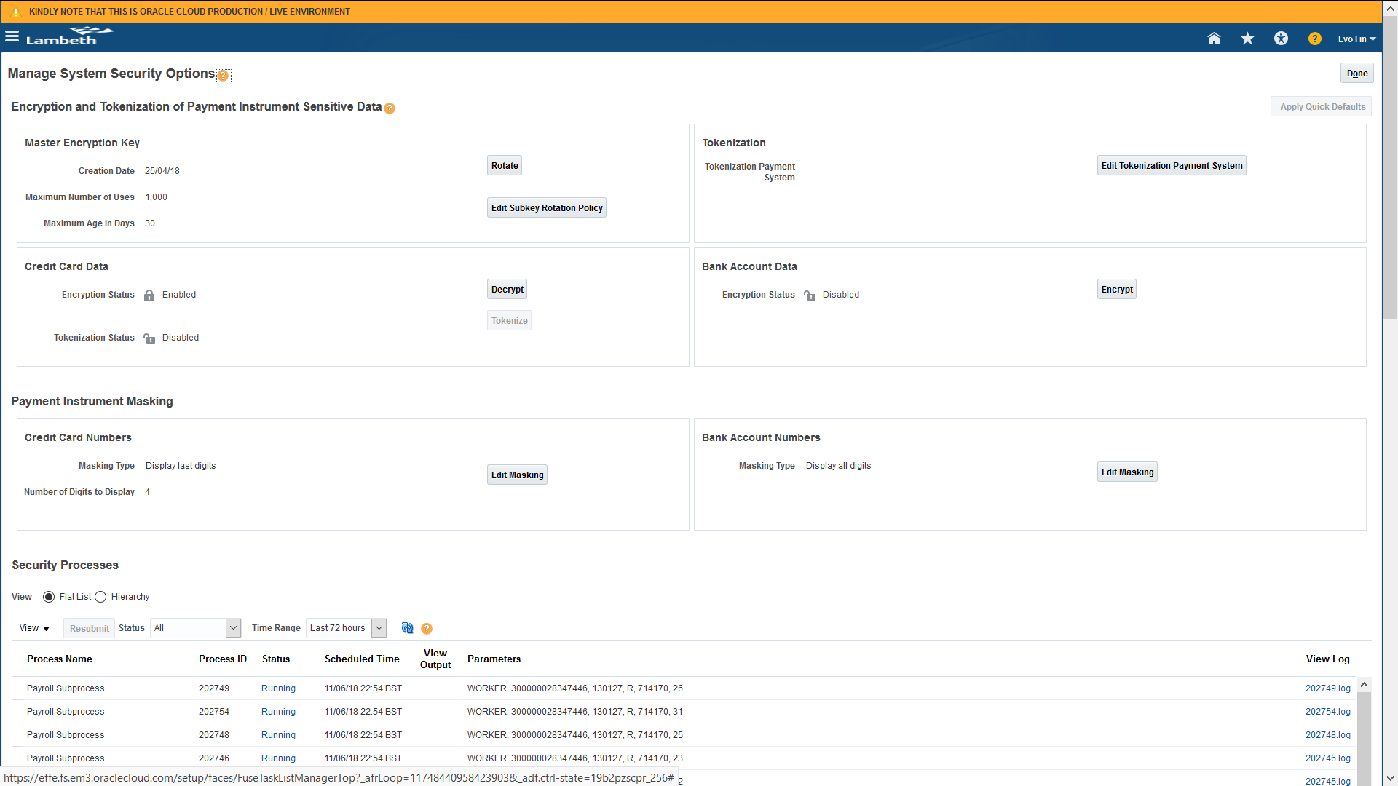
Click on Apply Quick Defaults to enable the Encryption for Credit Card Data.

Manage Corporate Card Issuer Product Codes
Lookup to create Credit Card Company Expense Types
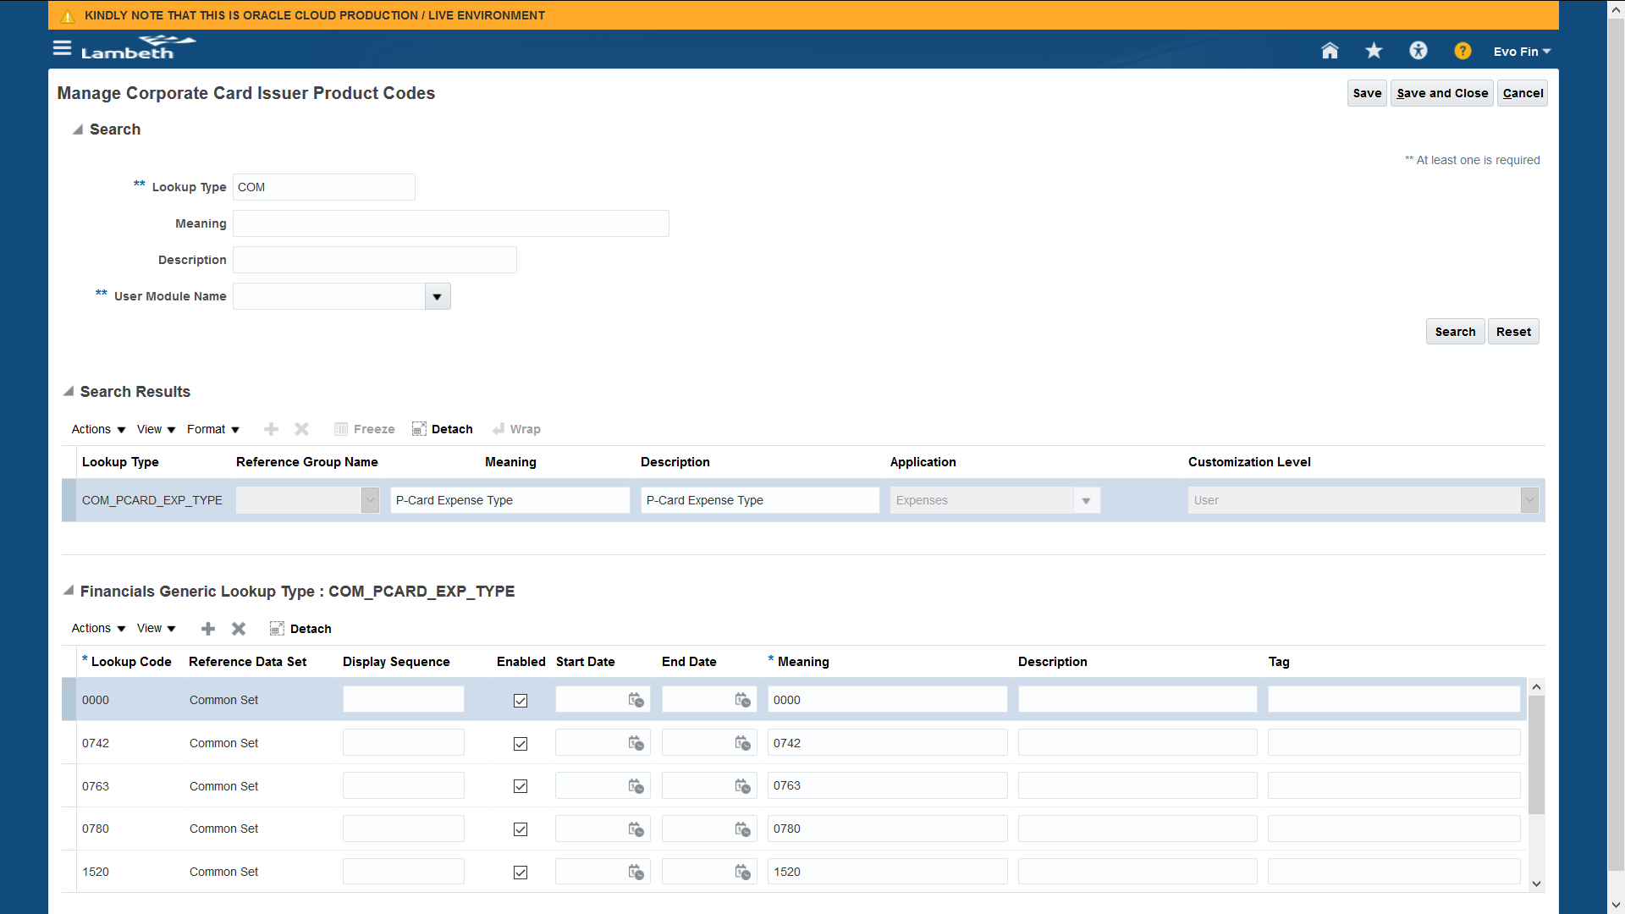
Manage Corporate Card Expense Types
Card Expense Type to be added in the Lookup
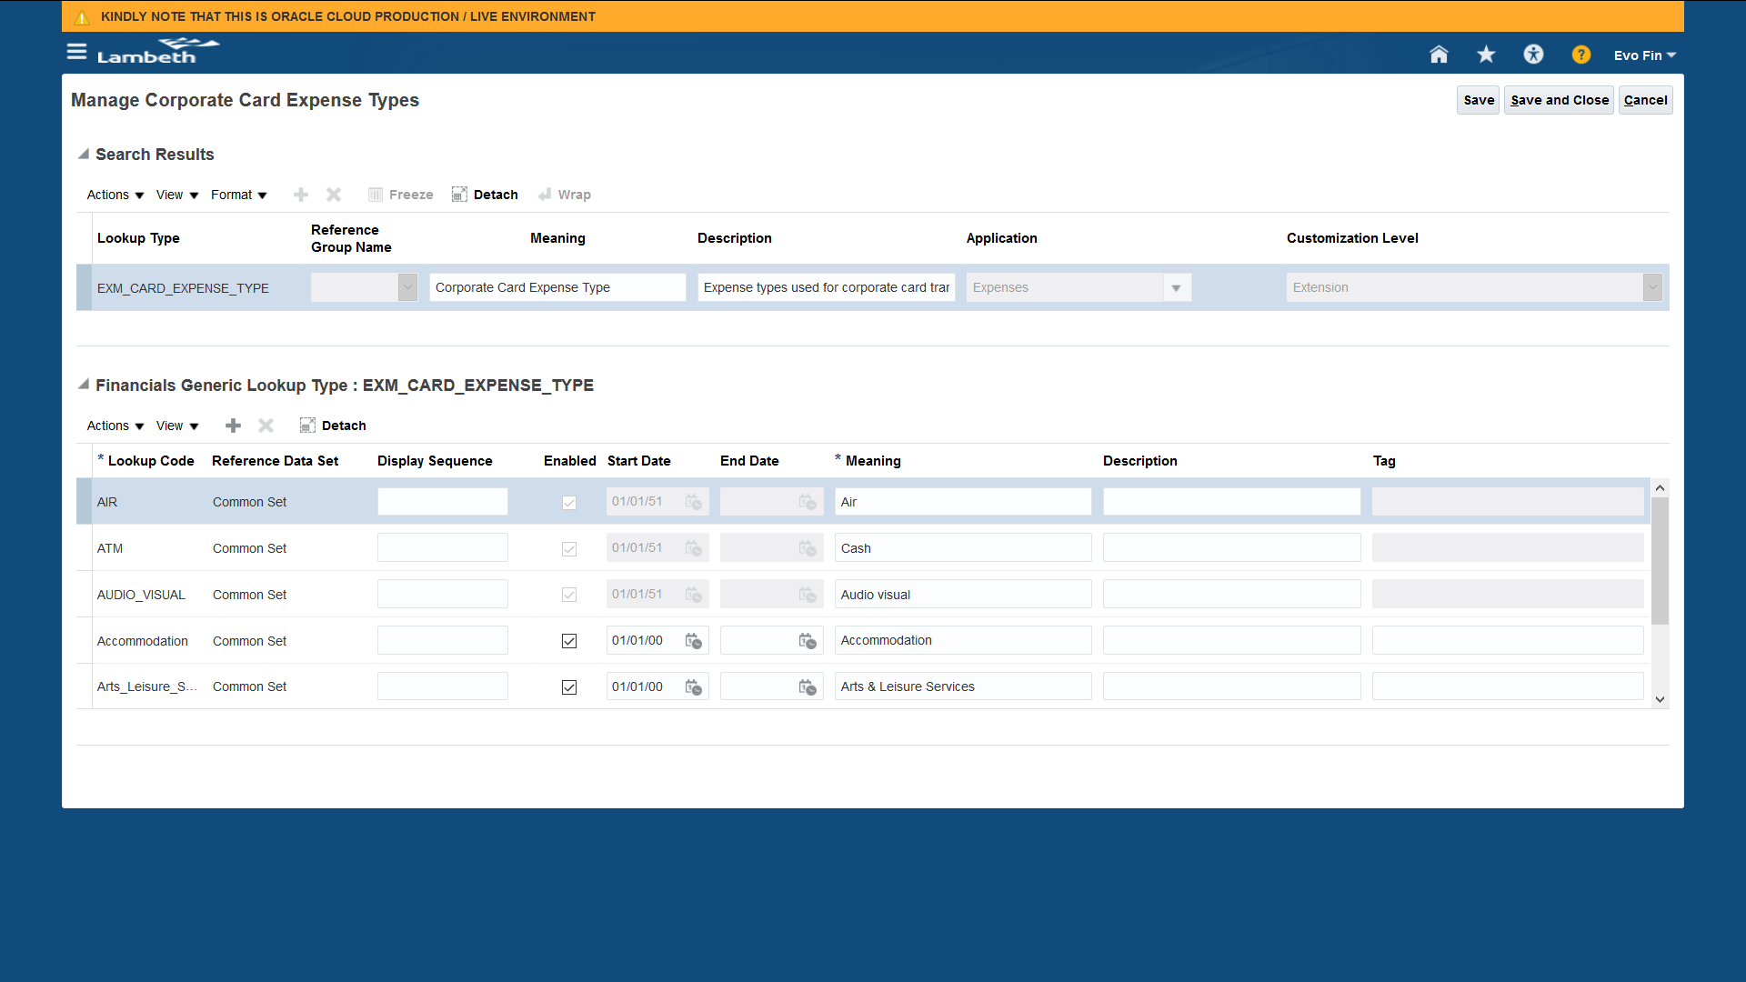
Manage Corporate Card Expense Type Mapping Rules
Card Expense Type to be mapped with Expense Codes provided by Credit Card Company
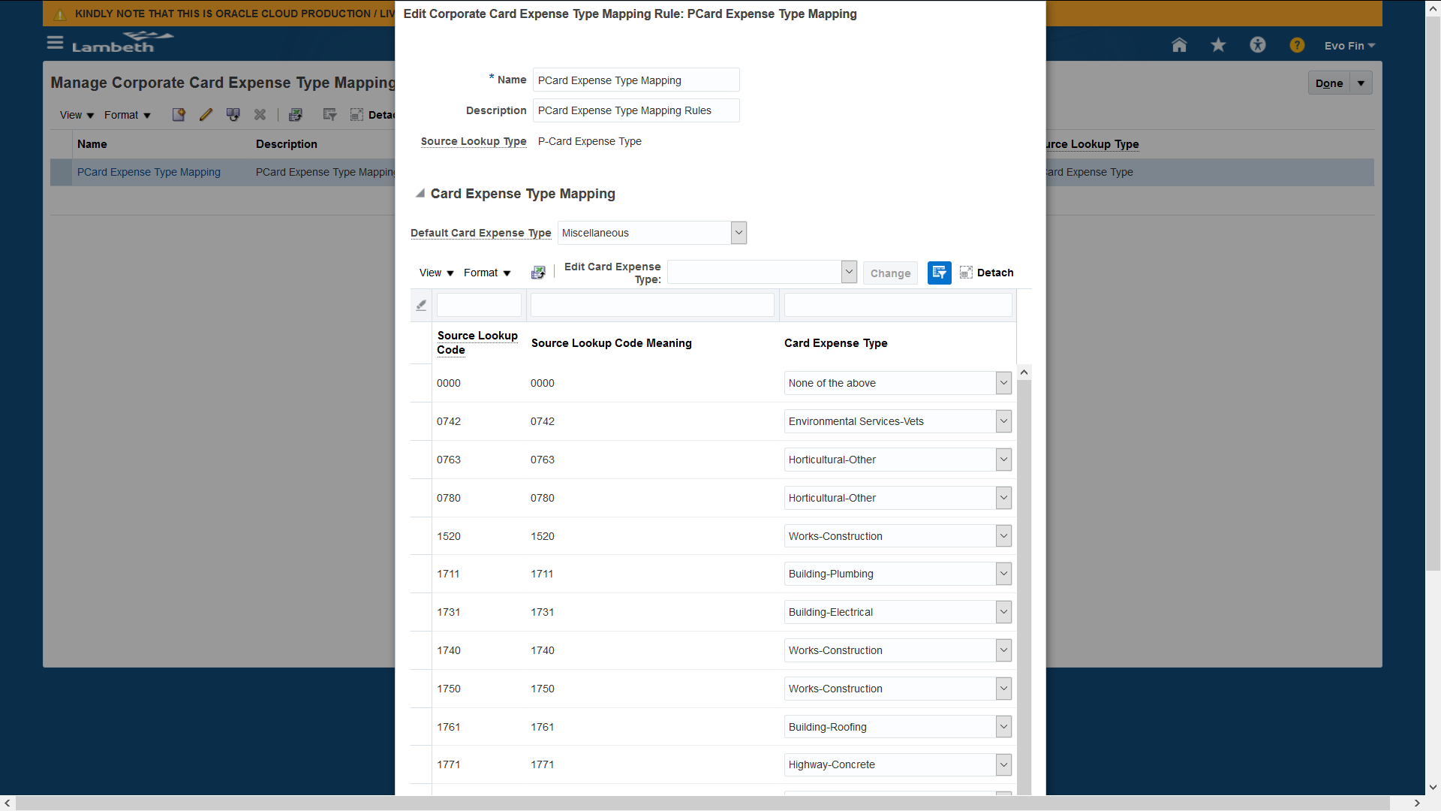
Note: - Expense Type mentioned in the "Default Card Expense Type" will be used if no mapping rule is available for any expense type.

Manage Corporate Card Expense Types Mapping
Mapping is to be created between Card Expense Type and Expense Type created in Expense Type Tab
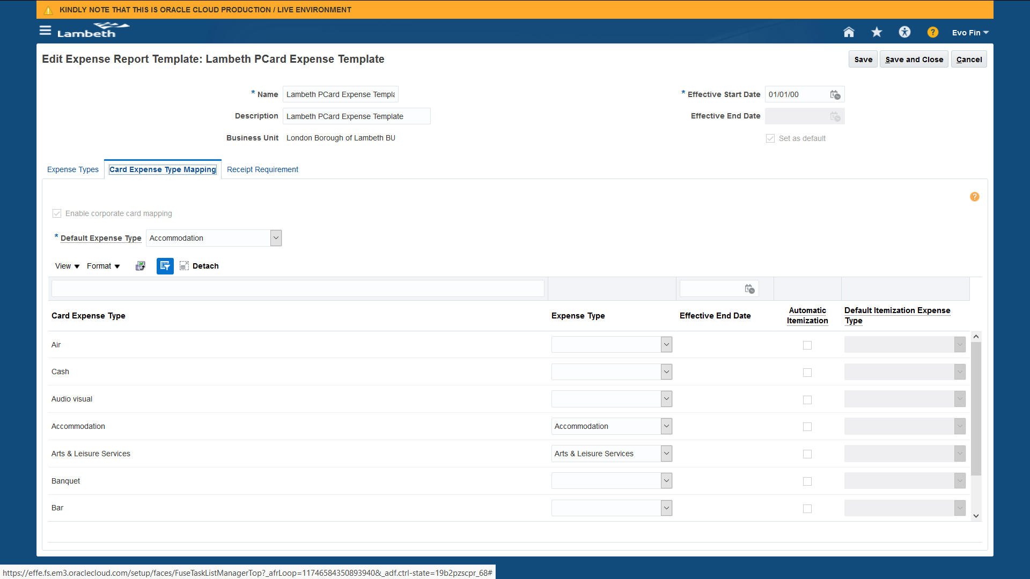
Manage Corporate Card Issuers
Setup of Corporate Card Issuer is to be made to raise an Invoice in its name. This will be created as a Party in the system which will be available for selection while performing setup of Corporate Card Program.
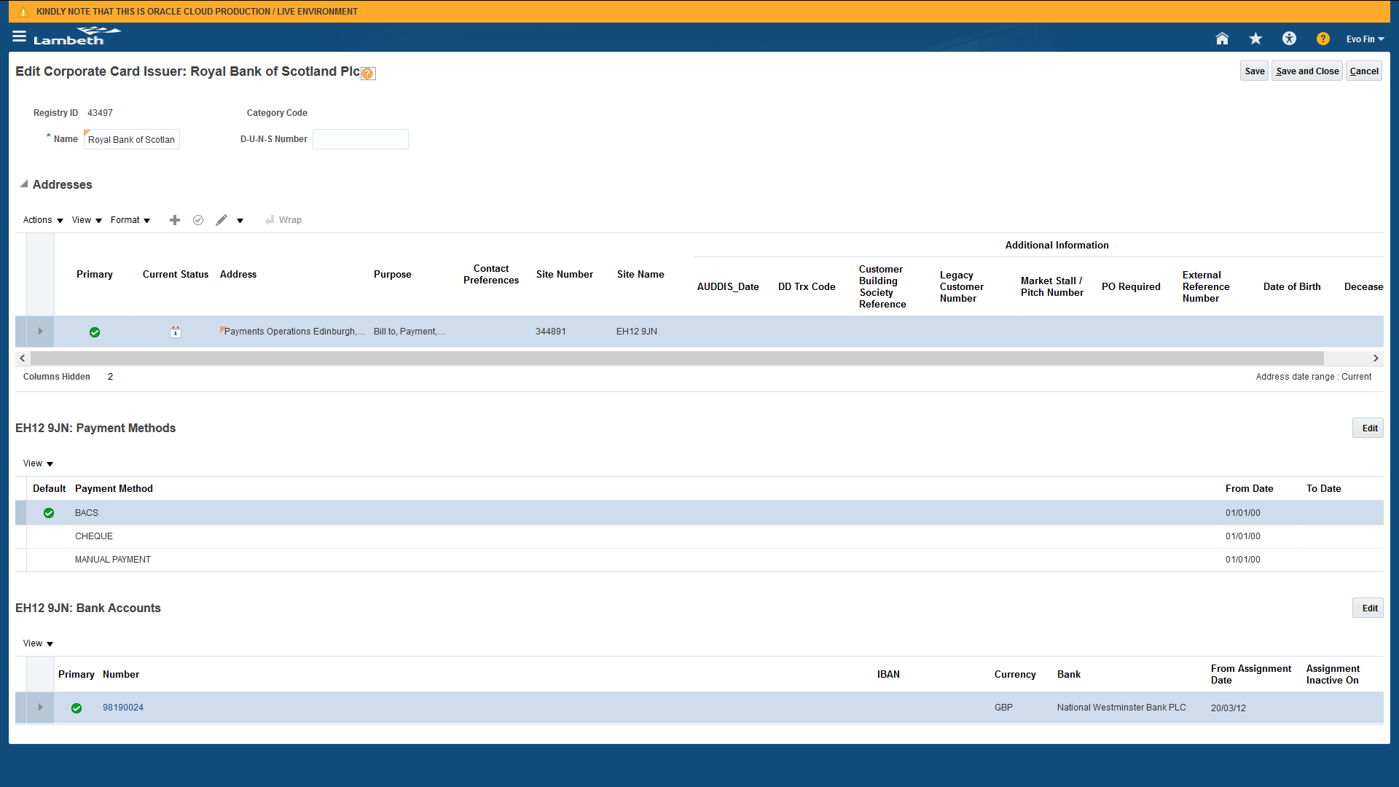
Manage Corporate Card Programs
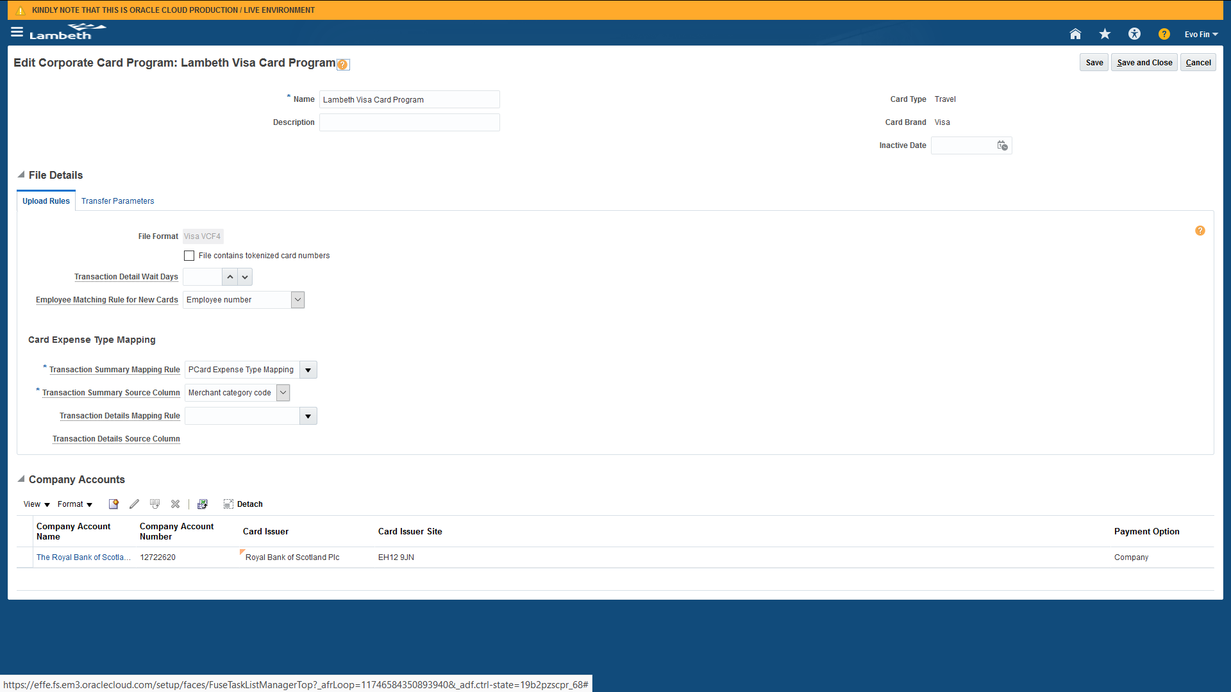
In Upload Rules tab, we can specify the file format and employee matching rules for new card (this will create a Corporate Card in the system if Employee number has been provided by Corporate Card Company correctly or it will create new card and we have to update Employee information to validate the Transactions in the system).

Card Expense Type Mapping
In this section, Mapping Rule which we have created in Manage Corporate Card Expense Type Mapping Rules is to be selected which will default the Expense Types while submitting Expenses.
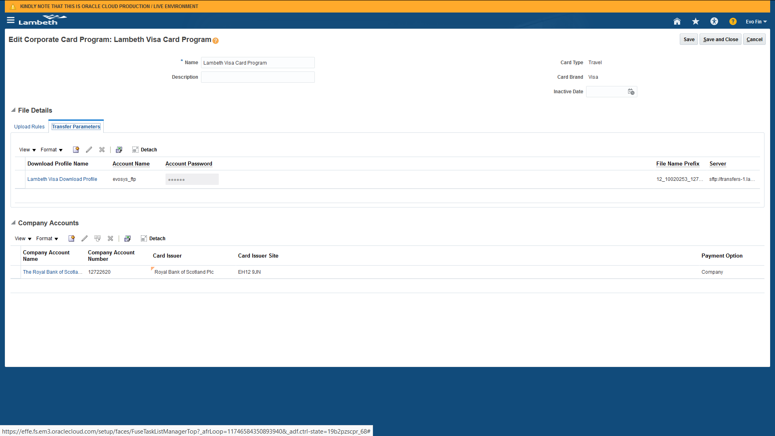
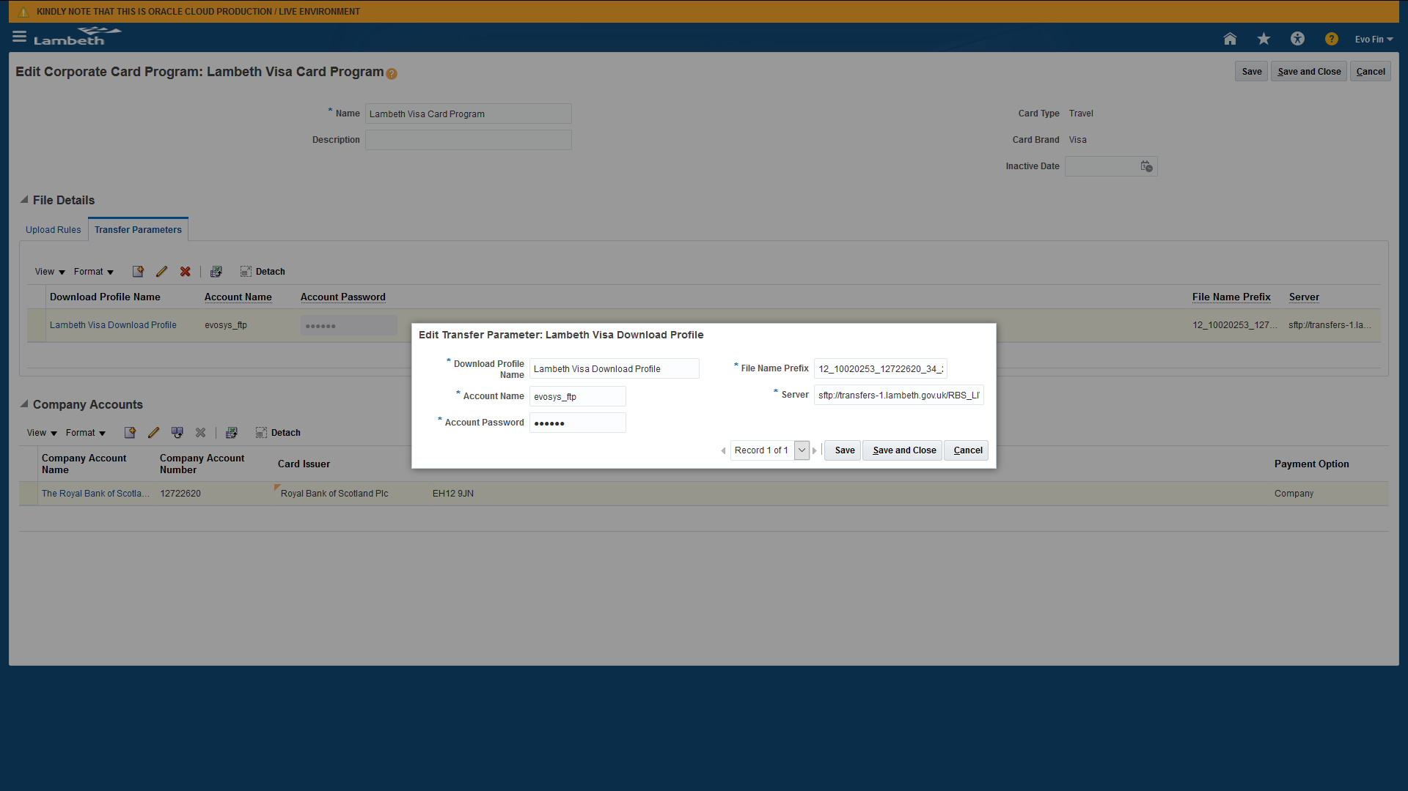
Transfer Parameters tab will have information related to SFTP or any other location from where the file is to be downloaded and uploaded into system.
In Release 12, File name Prefix will be the full file name in the system and not just prefix. It supports only STATIC file name. I am not sure about Release 13 that need to be checked.

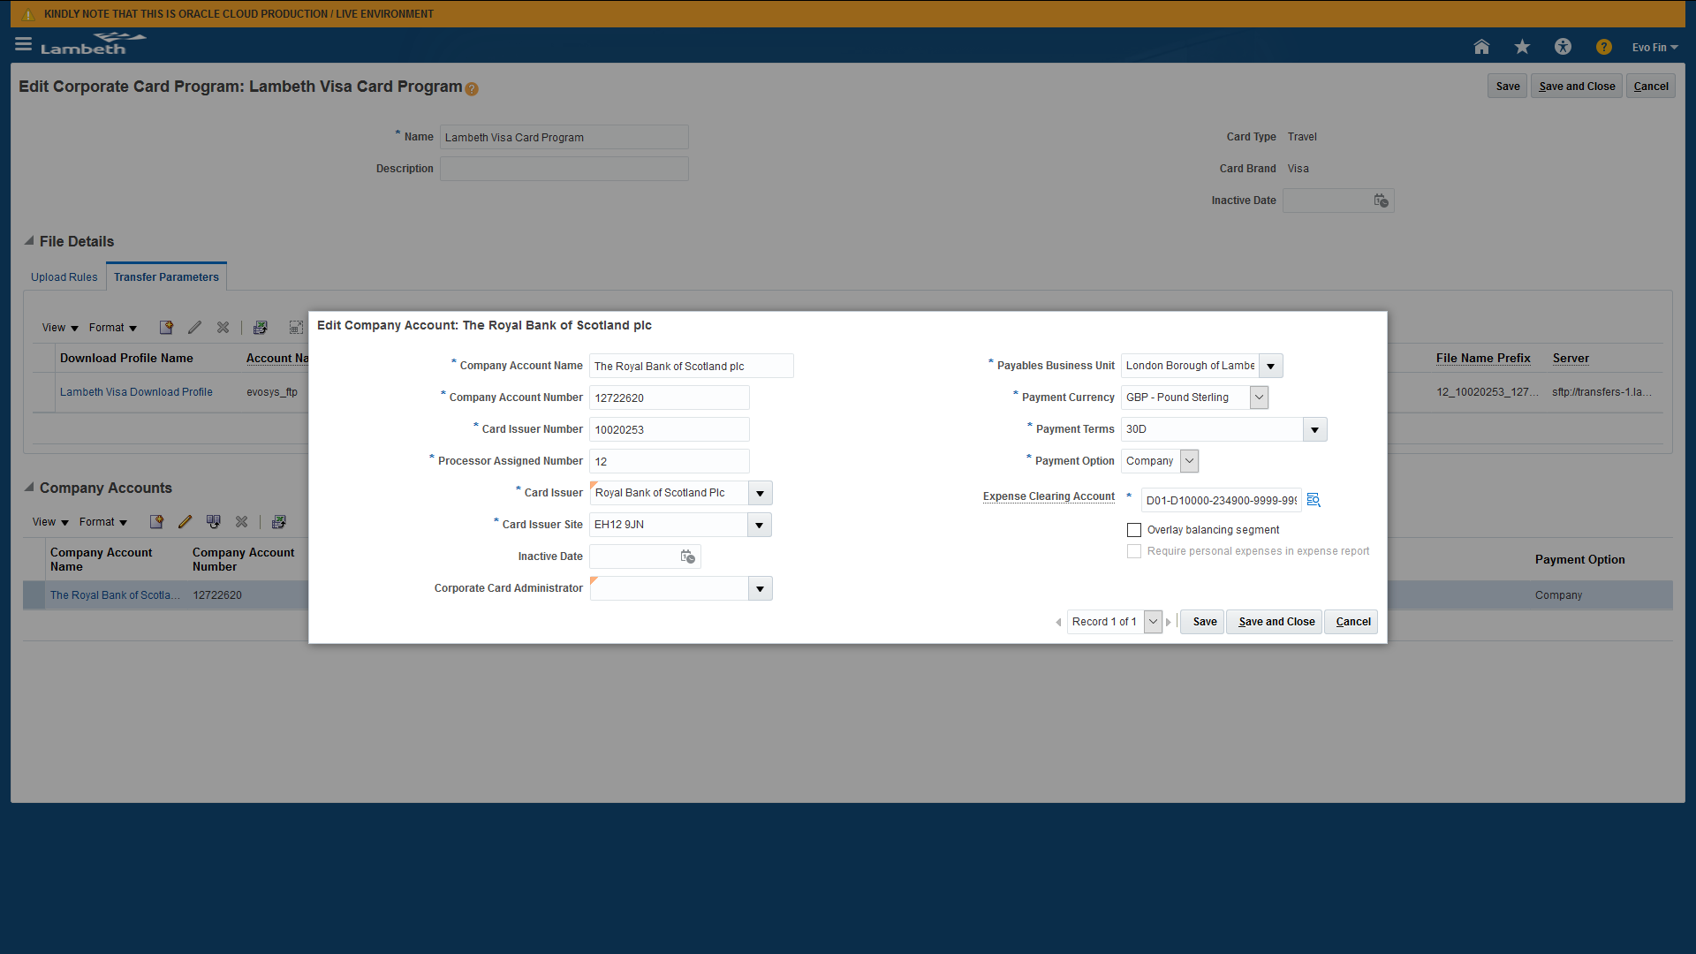
Deciding who is responsible for paying the corporate card issuer is an important decision. You can perform the setup from the above mentioned form.
Manage Corporate Cards
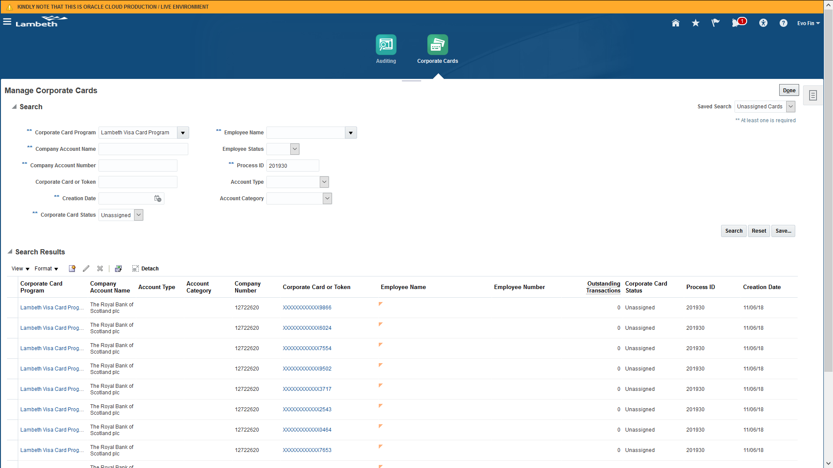
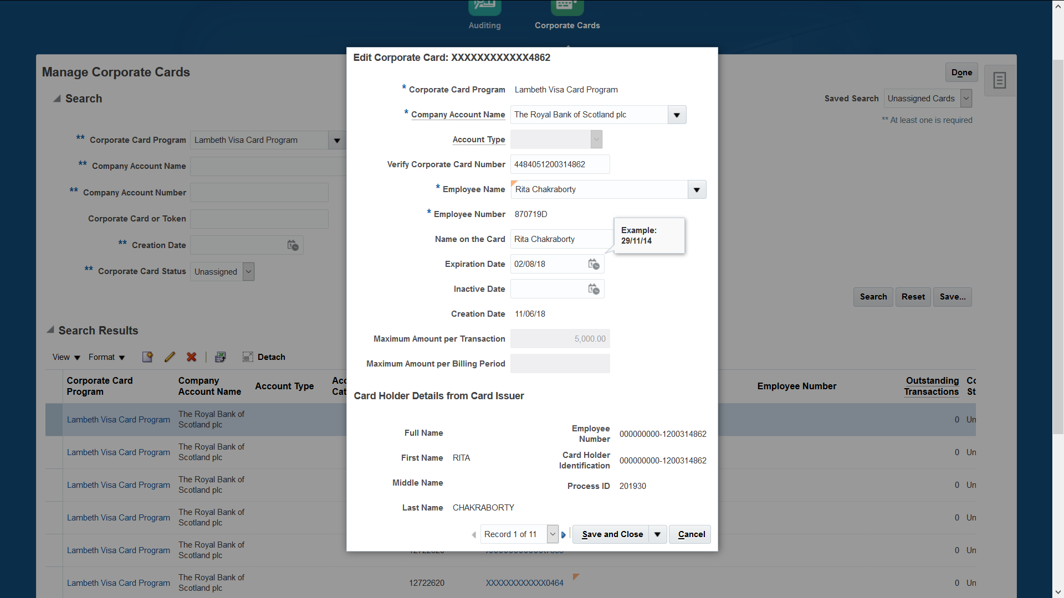

Upload Corporate Card Transactions
To upload Corporate Card Transactions, you can run the Request from Schedule Process “Upload and Validate Corporate Card Transaction File” or from Corporate Cards Dashboard whose access can be achieved using Corporate Card Administrator Role (to be assigned to used).
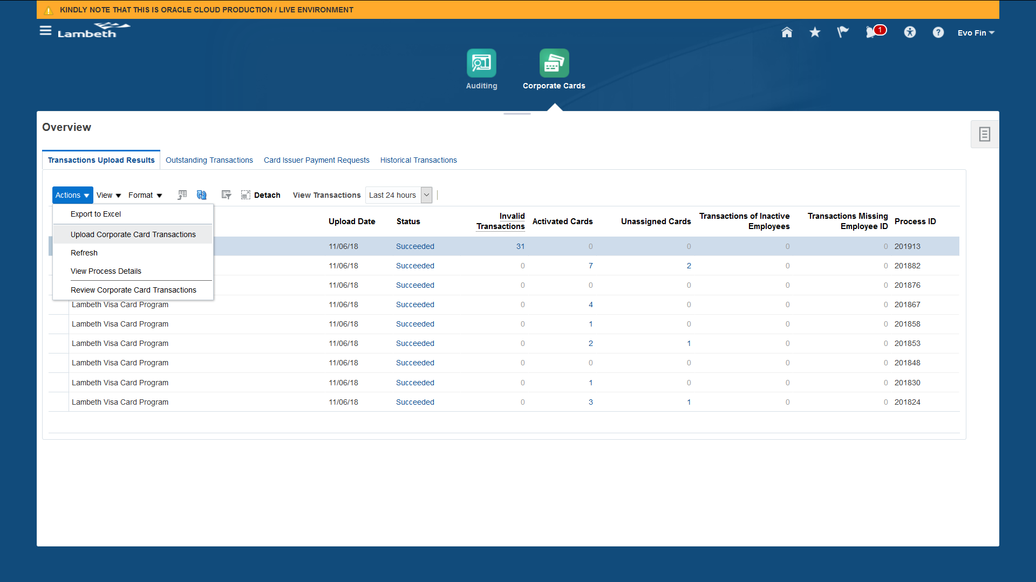
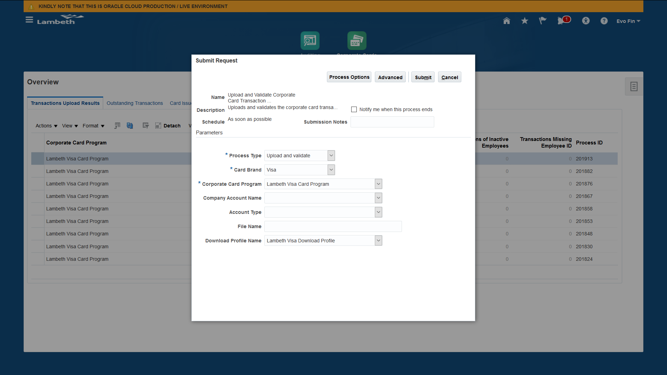
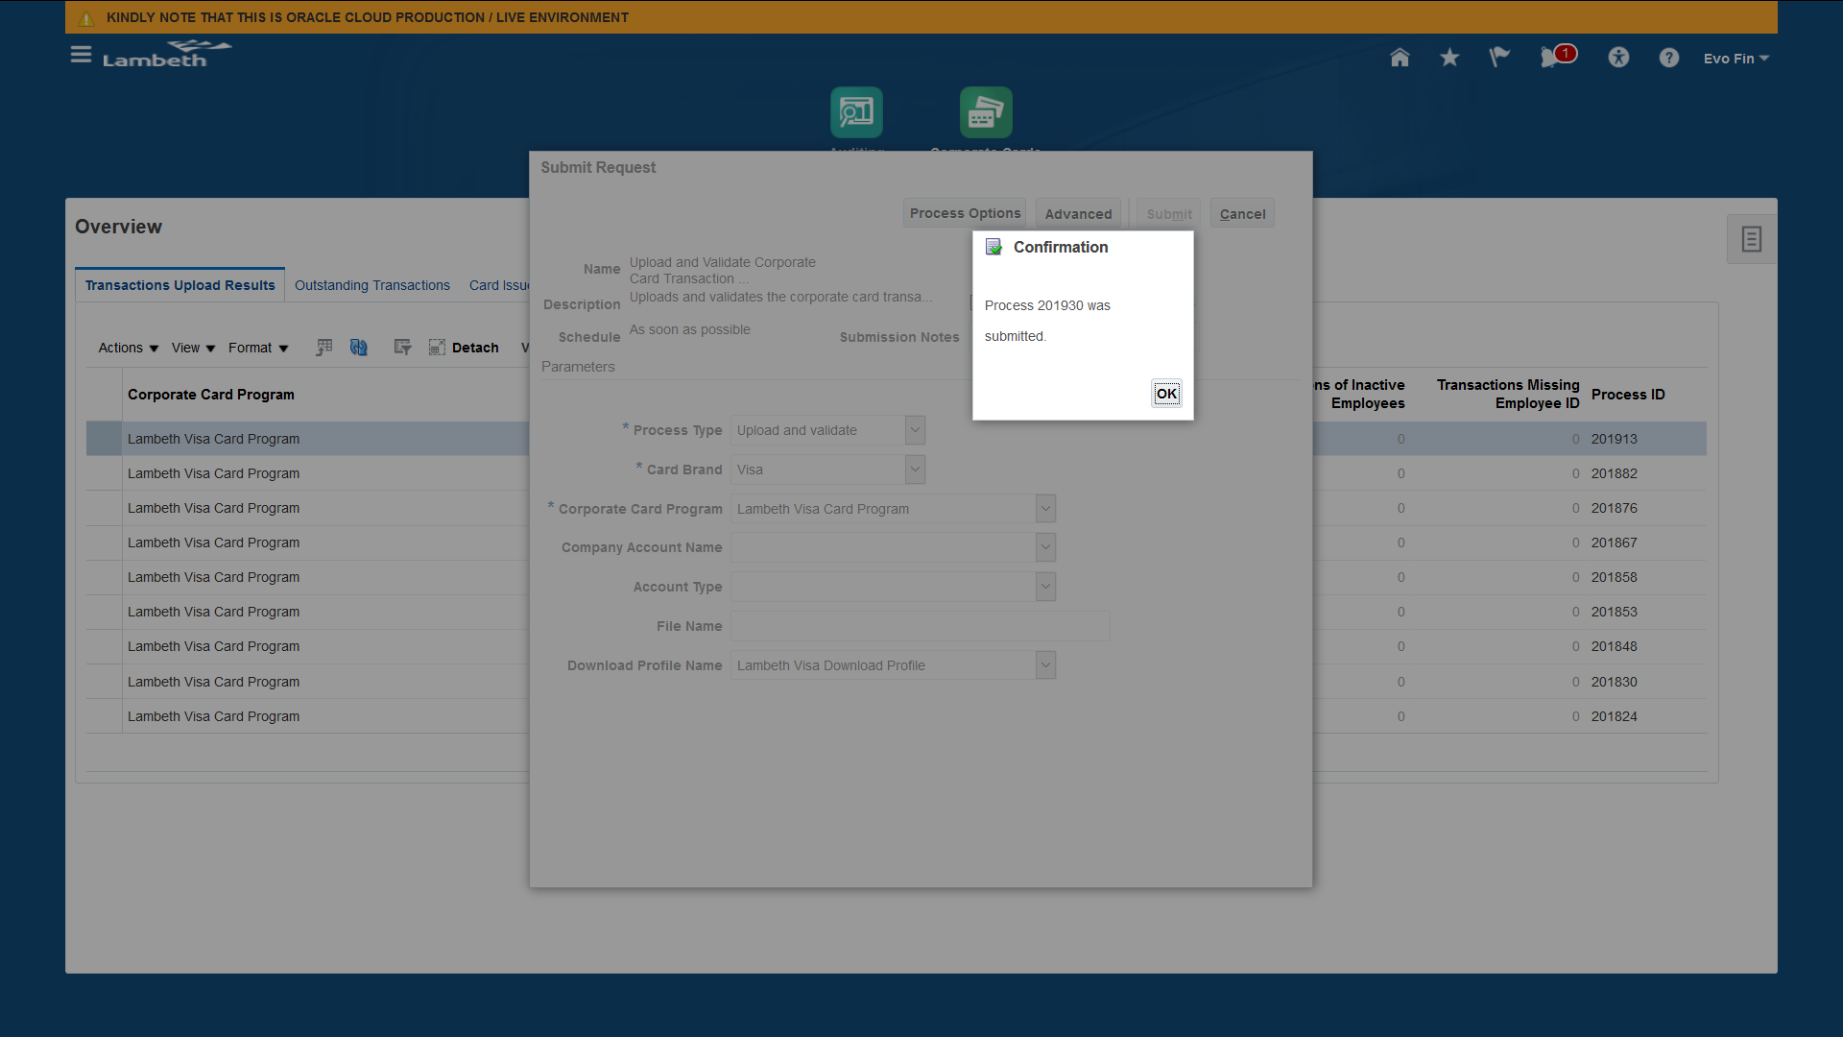
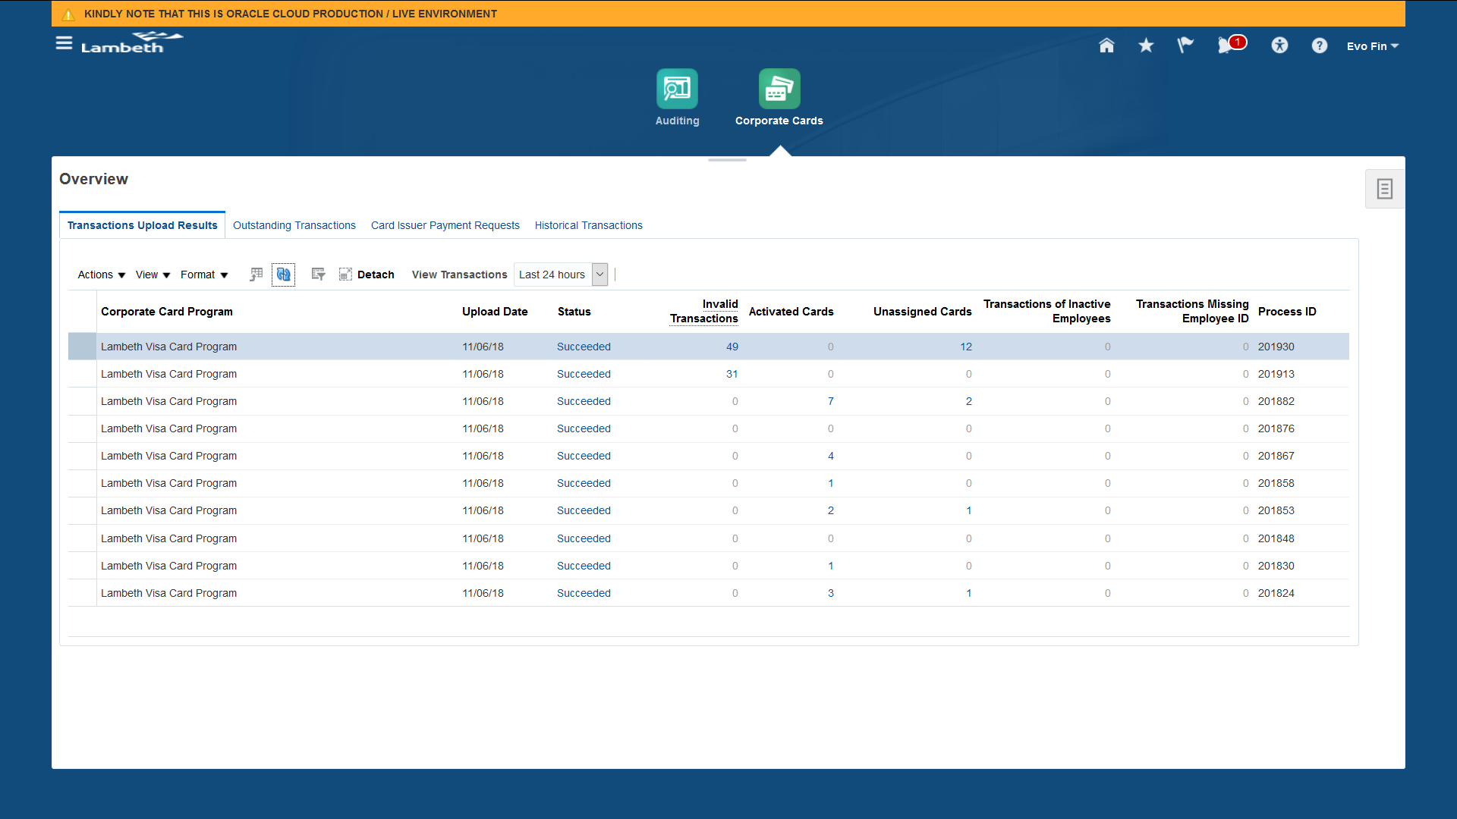
Once the file has been uploaded, it will not create those transactions whose corporate cards are not valid and active. Update the Corporate Card Information and run the same request with the parameter are validate only as show in below screenshot.
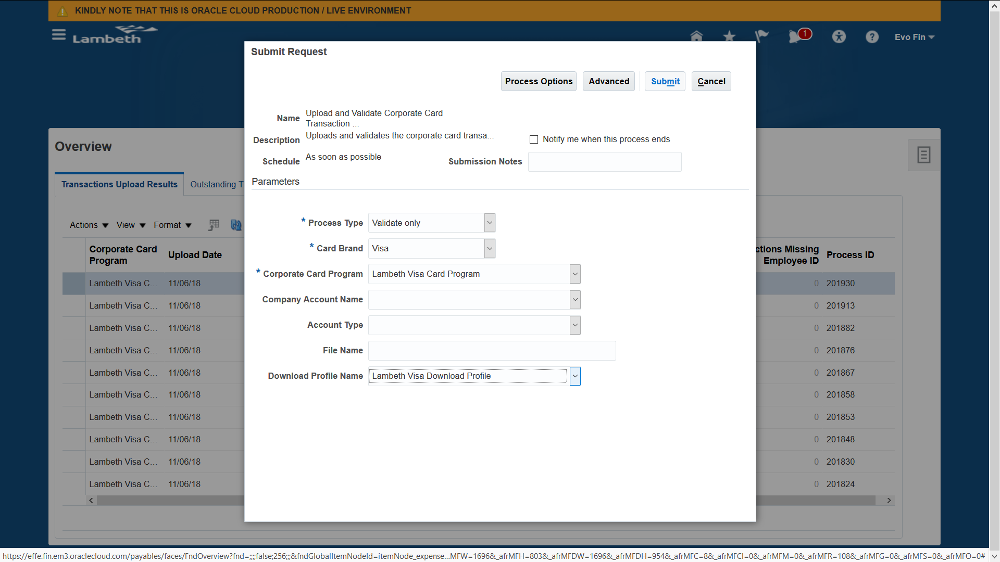
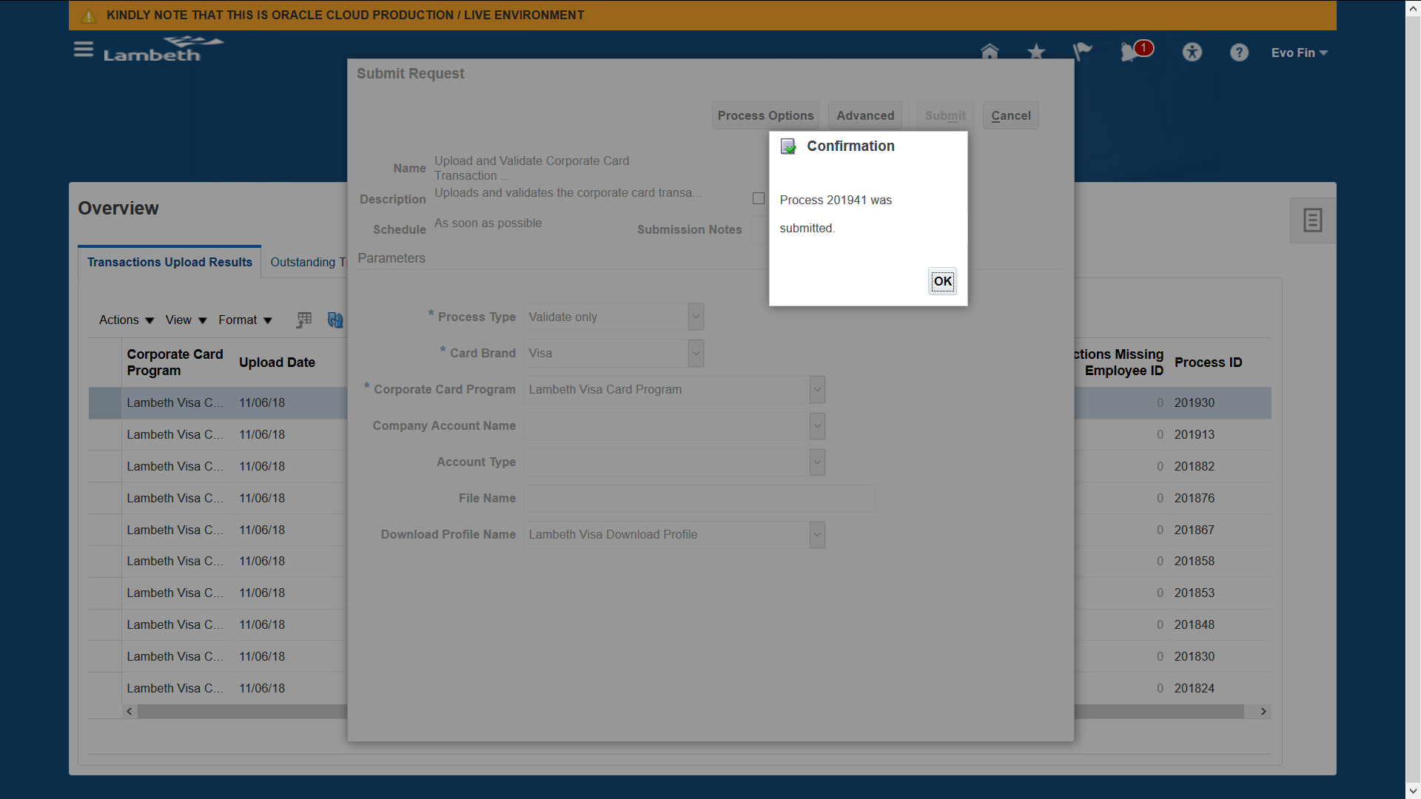

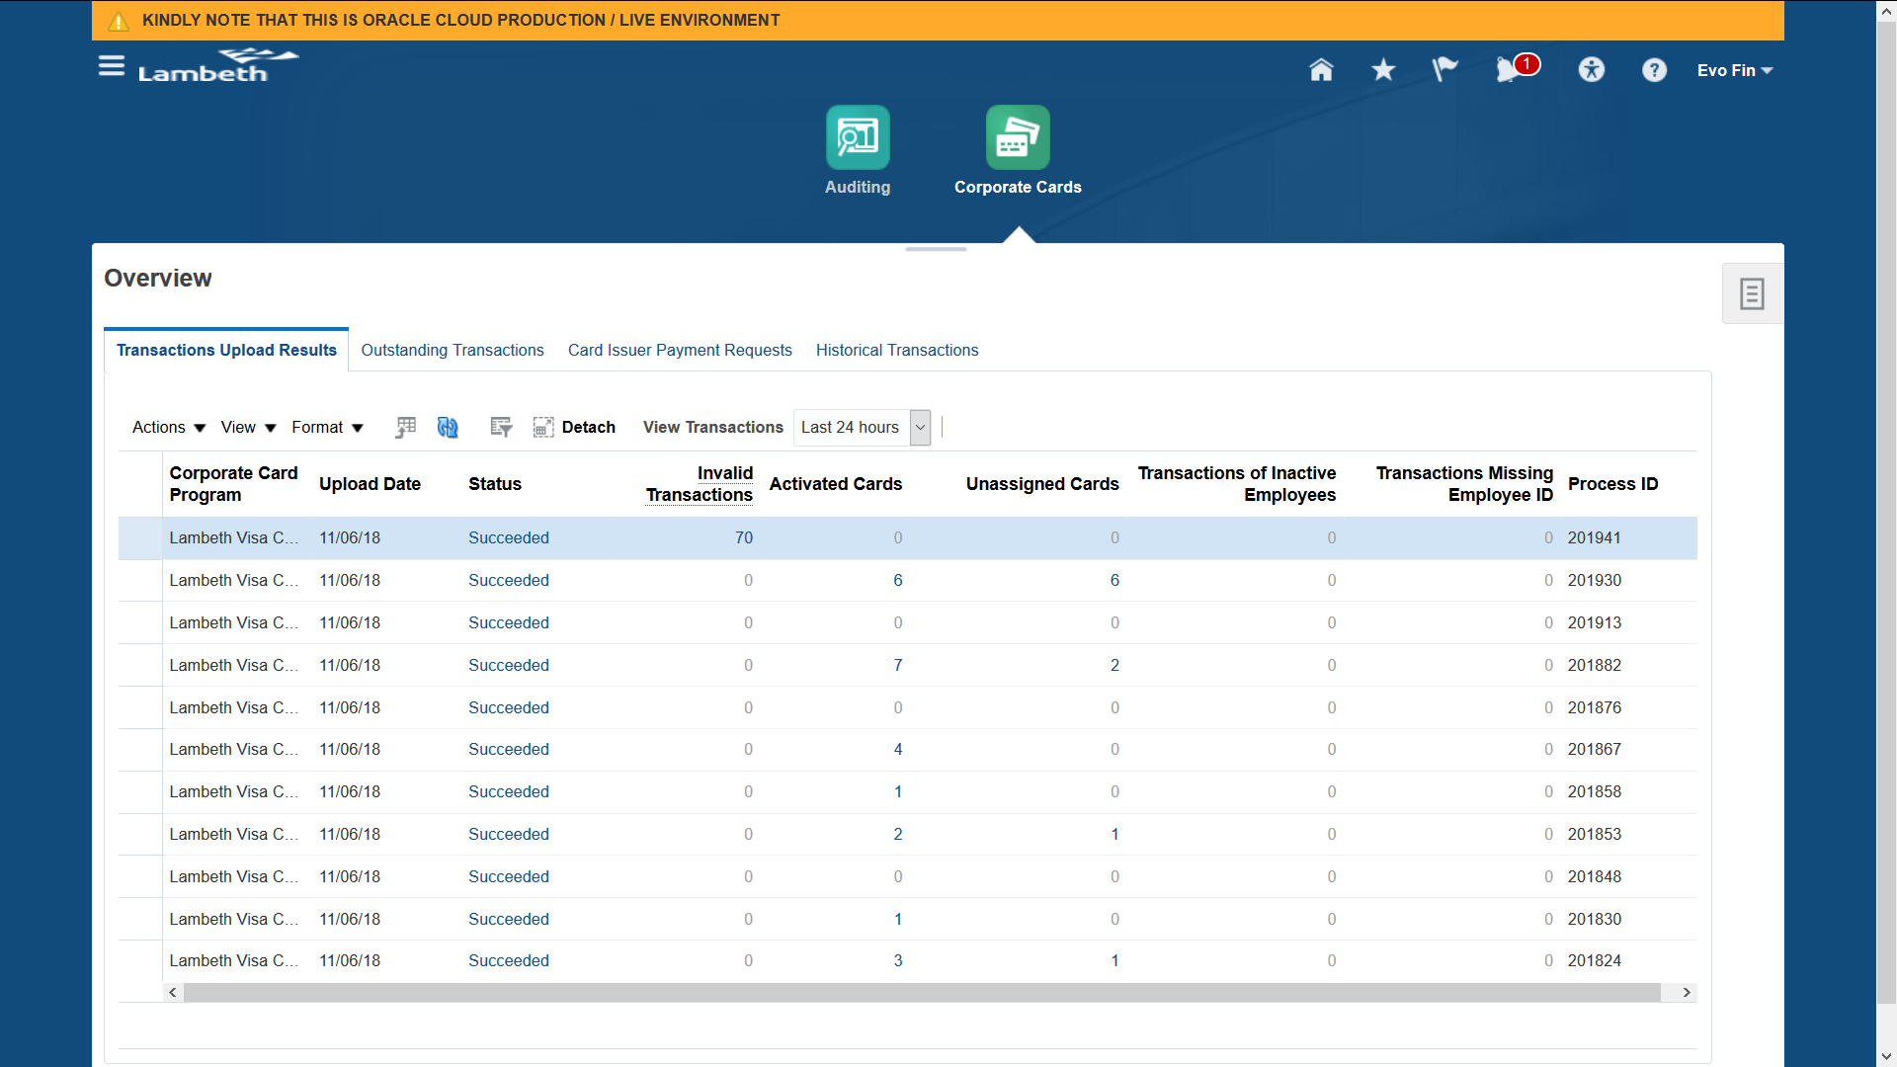
Review Corporate Card Transactions
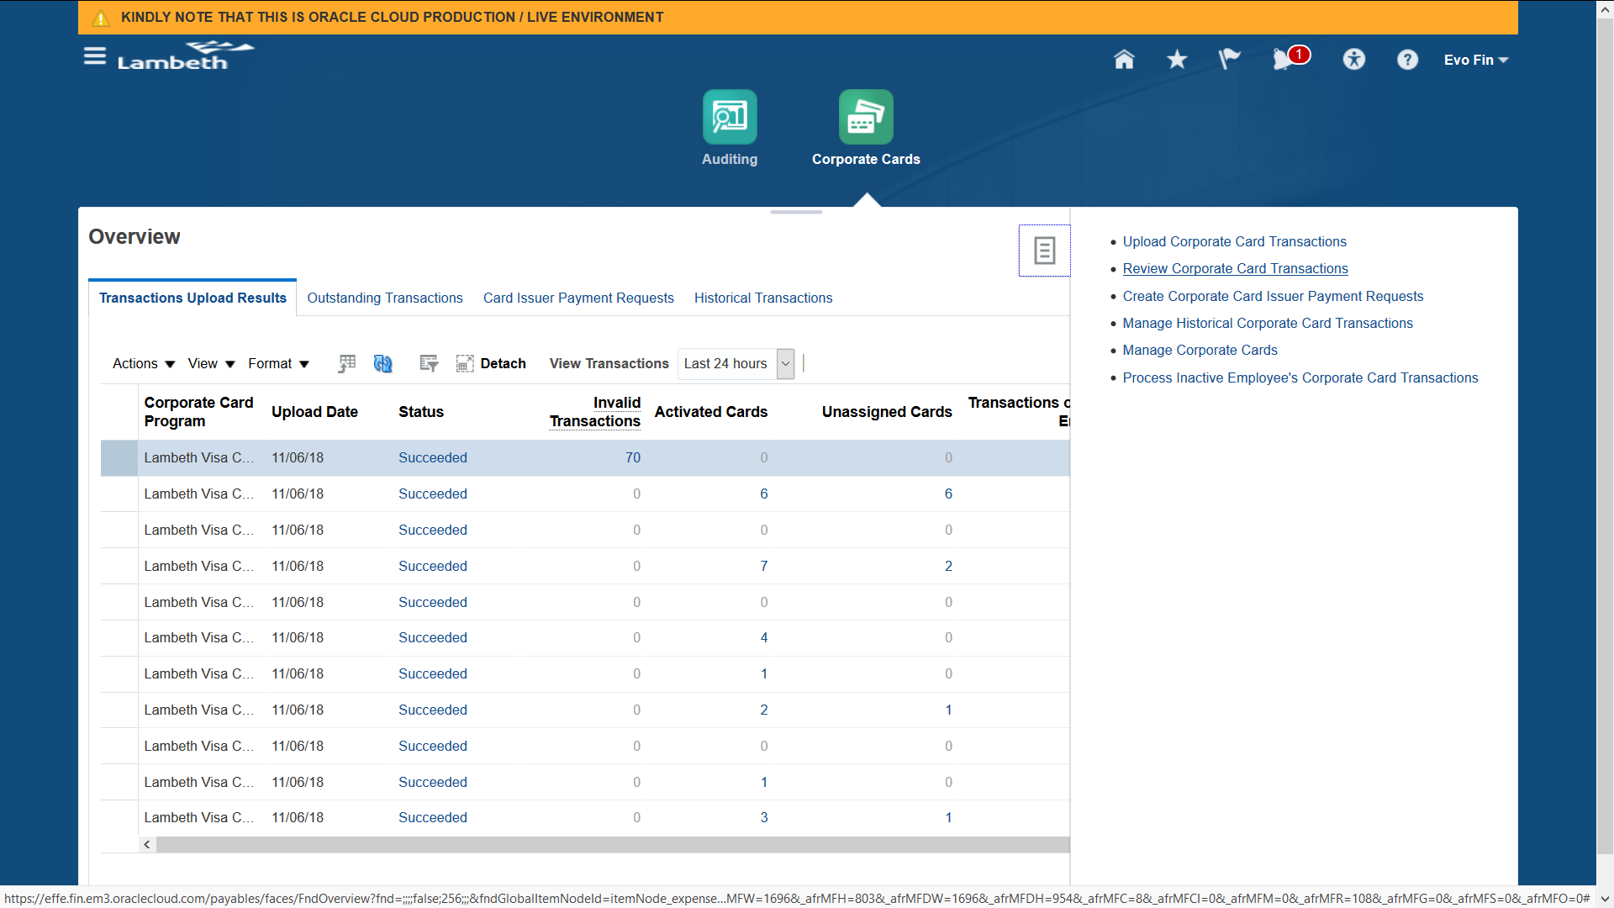
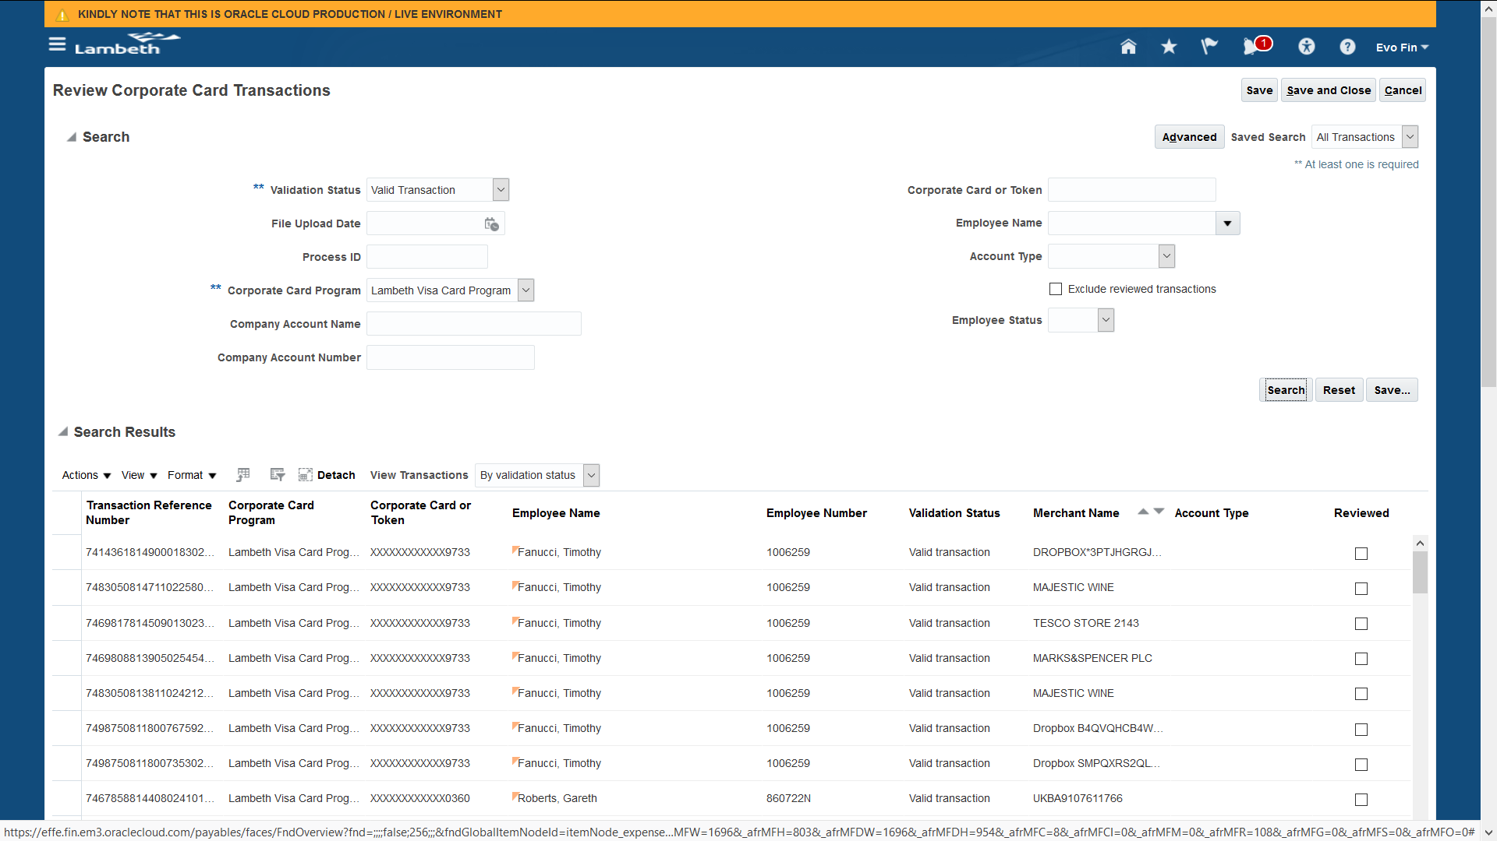
Outstanding Transactions
You can also review summary of Outstandaing Transactions (i.e. Transactions which are not yet submitted by Users) from Manage Corporate Cards.
